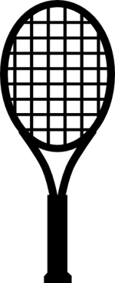

 **Autumn**

**Tennis**

**BEGINS: Wed & Thurs, September 13th & 14th**

**Sept 13,14, 20,21 27,28 Oct 4,5,11,12 Finals: Oct 19th**

|  |  |  |  |  |
| --- | --- | --- | --- | --- |
| **Surname** |  | | | |
| **First Name** |  | | | |
| **Gender** | **Male ** | | **Female ** | |
| **Contact No:** |  | | | |
| **Email Address** |  | | | |
| **Are you willing to be a captain** | Yes  No  | | | |
| **Playing Level** | **1  2  3  4 ** | | | |
| **Do you wish**  **to PLAY?** | **EITHER night ** | **WED only ** | | **THURS only ** |
| **Are you willing to SUB?** | **EITHER night ** | **WED only ** | | http://cache3.asset-cache.net/gc/165900513-rainforest-animals-gettyimages.jpg?v=1&c=IWSAsset&k=2&d=XDBH0XNcx3ixbUWhIz2z56FybB1hvayEifJKk5P6sVo%3D **THURS only ** |

**CLOSING DATE: All Application Forms and Entry Fee of €10 must be submitted in an envelope into the Tennis Club Post Box in the Caddy Master’s area, or emailed to** [eptennis2017@gmail.com](mailto:eptennis2017@gmail.com) **before 21:00 on**

**Wednesday, September 6th 2017**

**Competition Rules: The Rules of the competition will be posted on the**

**Elm Park Tennis Website: www.elmparkgolfandsportsclub.ie**

**Substitution Rules: In the event you cannot play, it is your**

responsibility **to find a substitute player at the correct level.**

**The Ten Minute Rule will be enforced (See competition rules).**

**Signature ­­­­­­­­­­­­­­­­­­­____________________________ Date _____________**

**Have you remembered to include your €10 with your entry form?**